# May 2025

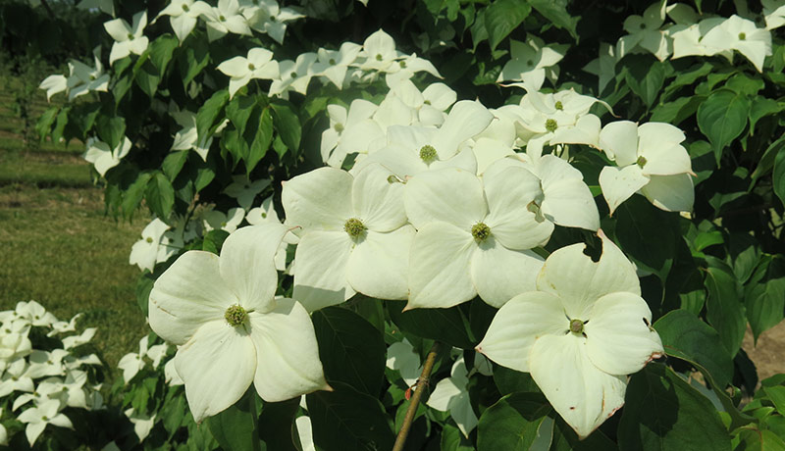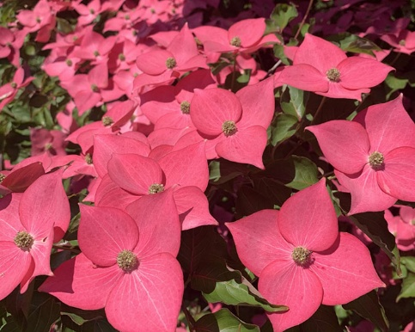Rutgers Develops New Hardy Dogwood Varieties That Sparkle  
On May 20, Thomas Molnar, associate professor in the Department of Plant Biology, who led the development of Fire® that was introduced to consumers through commercial nurseries about five years ago, [formally unveiled the latest additions to the university’s dogwood program](https://sebsnjaesnews.rutgers.edu/2025/05/plant-breeders-stage-a-dogwood-revolution-creating-hardy-varieties-that-sparkle/): Stellar Nova ™, a bright white blooming hybrid, and Eternal Scarlet ™, with blooms of a rich, saturated red tone. Their hues complement Scarlet Fire® and promise to add more color and diversity to the landscape. They also possess highly reflective petals, presenting a dazzling show when struck by the sun. In addition to being a boon for commercial nurseries and garden centers, the hybrids, as with their forebears, are expected to become a popular addition to landscapes and gardens, adding a splash of vibrant pink and red colors in late May when few flowering trees are in bloom. According to the [New Jersey Nursery and Landscape Association,](https://www.njnla.org/) New Jersey’s green industry contributes more than $4 billion to the state’s economy annually.

Stellar Nova™ (at left) complements Eternal Scarlet™, with both blooming much later than most ornamental trees.

# Rutgers Farm Health and Safety Working Group Conducts “Stop the Bleed” Training

[Two “Stop the Bleed” training sessions for the New Jersey agricultural community were conducted](https://sebsnjaesnews.rutgers.edu/2025/05/rutgers-farm-health-and-safety-working-group-conducts-stop-the-bleed-training/) by the Rutgers Farm Health and Safety Working Group. The sessions included a presentation on the ABCs of bleeding control and hands-on practice with pressure application, wound packing, and use of a tourniquet. This training is timely as blood loss is the leading cause of preventable death where a medical response is delayed and farming can be an inheritably dangerous occupation, especially due to the use of large farm equipment. The group is comprised of RCE agricultural agents **Kate Brown** (Somerset County) who also chairs the group, **William Bamka** (Burlington County), **Michelle Infante-Casella** (Gloucester County), and **Stephen Komar** (Sussex County).

# Course Focuses on the Importance of Bee-Positive Environmental Practices

Through their spring “Apiculture” class,**Michael Haberland** and **Debra Haberland** [convey the critical importance of honey bees to students and the public](https://sebsnjaesnews.rutgers.edu/2025/05/couple-teaches-the-importance-of-bee-positive-environmental-practices/). Over nearly a decade, Haberland and his research partner, his wife Debra, have developed a deep understanding of bee behavior. Haberland uses applied research and collaborates with organizations to develop programs that promote innovative, bee-positive environmental practices. By conducting research that is advancing queen bee fertility, they hope to preserve honey bees’ existence. By teaching beekeeping classes to undergraduates and the public, they aspire to convey the vital role honey bees play in the Earth’s ecosystem. The couple’s work is a blend of scientific research, education, and environmental advocacy, all aimed at ensuring the health and sustainability of honey bee populations.

# Of Interest

The following updated fact sheets are available on [NJAES Publications](https://njaes.rutgers.edu/pubs/):

[FS221: Asparagus Beetles](https://njaes.rutgers.edu/fs221) **Nitzsche, P.**

[FS224: Colorado Potato Beetle](https://njaes.rutgers.edu/fs224/) **Nitzsche, P.**

[FS1365: Blueberry Integrated Pest Management Delivery Program](https://njaes.rutgers.edu/fs1365/) **Spies, J.**and **Mansue, C.**

[FS1368: Kids in the Kitchen](https://njaes.rutgers.edu/fs1368/)  
**Salt Taylor, J.**

# Accomplishments Rutgers Environmental Stewards Program Marks 20th Anniversary

[Since 2005](https://envirostewards.rutgers.edu/program-overview/program-accomplishments/), the Rutgers Environmental Stewards Program has trained more than 1,200 volunteers, completed 316 projects with more than 50 partnership organizations, engaged in over 22,000 hours of environmental service across the state, contributed over $860,000 in conservation value and impact to partnership projects, and created or enhanced 145 habitat sites through natural resource activities. The program trains individuals in the community to become leaders in environmental practices and also spreads awareness about pressing environmental issues, such as conservation and sustainability, to a broader audience, creating a more environmentally conscious public and strengthening local environmental impact. Participants are educated on practical ways to address challenges from water quality to wastewater management. The program creates a network of trained environmental stewards who collaborate across the state sharing expertise and resources. This collaborative approach strengthens the overall environmental efforts within New Jersey, ensuring that sustainable practices are integrated into different communities.

**Congratulations to our Graduates**

Congratulations to all our graduates! Over the past year, SEBS students engaged in experiential learning across campus and NJAES facilities in New Jersey and across the country. Their projects ranged from completing original research in the lab and field, to creating content for public-facing organizations, to providing support for both SEBS and NJAES faculty and staff. This year, eight outstanding SEBS undergraduates were recognized for their exemplary achievements in leadership, scholarship, and service. Valedictorian: **Victoria Wei** (Environmental Planning); Salutatorian: **Bhavya Prakesh Gupta** (Biochemistry). The GH Cook Leadership Awards for excellence in research, entrepreneurship, or outreach were presented to **Brendan Henley** and **Elise Schicker**. The Cook Community Alumni Association Award, honoring commitment to community, service, academics, social justice, and diversity, went to **Brooke Mackie** and **Andrea John**. The Roy DeBoer Leadership Award, celebrating exceptional dedication to leadership, mentorship, meaningful community impact, and campus engagement, was awarded to **Renee Proccacini** and **Kush Patel**. Our graduating Ph.D. and M.S. students were well represented in the Rutgers School of Graduate Studies awards this year. **Joseph Gradone** (Oceanography, advisor: Travis Miles) won one of the Outstanding Doctoral Student Awards, **Emily Hanselman** (Nutritional Sciences, advisor: Paul Breslin) won one of the Excellence in Leadership and Teaching Awards, and **Chintan Bhavsar** (Nutritional Sciences, advisor: Tracy Anthony) won one of the Outstanding Master’s Student Awards. *Rutgers New Jersey Agricultural Experiment Station is an equal opportunity program provider and employer.*