# June 2025

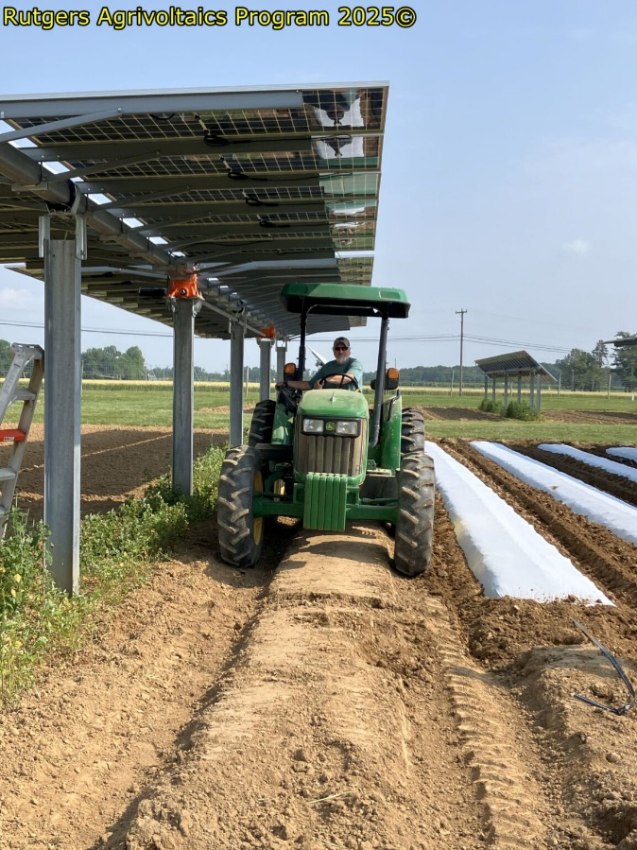Update on Rutgers Agrivoltaics Program   
The [**Rutgers Agrivoltaics Program**](https://agrivoltaics.rutgers.edu/) is a multidisciplinary group of university faculty and staff committed to designing and conducting applied agrivoltaics research and outreach. The second year of specialty crop research at the **Rutgers Agricultural Research and Extension Center** (RAREC) in Upper Deerfield, NJ, began in late March. The specialty crop trial done this summer at RAREC will be similar to the trial in 2024 so as to acquire two years of data for statistical analysis. Following the harvesting of the spring spinach trial, the ground for the second-year trial was prepped on June 4, with the discing and spading of the plot areas and the application and incorporation of 80lbs. N/acre of 14-4-14 pre-plant fertilizer. On June 6, raised beds consisting of white on black plastic mulch were laid with drip irrigation set off-center. Given the record-breaking drought in the fall of 2024, Rutgers scientists anticipate that this growing season will enable expanded data collection over different weather conditions.

Plastic mulch being laid beneath a single AV panel in the research plot at RAREC.

# Integrating Agriculture and Artificial Intelligence

Rutgers University is engaged in a number of projects focused on the use of artificial intelligence (AI) as it relates to agriculture. The USDA-funded project, “AI on the Bog,” led by Kristin Dana, professor in the Rutgers School of Engineering, is scheduled to be completed at the end of this fiscal year. The goal of the project is to develop tools to help cranberry farmers manage the risk of fruit overheating in the sun. Drones were used to capture images of cranberry beds and applied AI to count the berries and estimate the areas that were most vulnerable. This work has led to a new project called “The Breeders A-Eye,” which monitors cranberry growth from flowering through harvest to help breeders quickly identify and select the most promising plant traits. Another related project focuses on detecting Fairy Ring, a common cranberry disease, using drone imagery. With this approach, even small infections can be spotted early and treated effectively. This effort is a collaboration with Hieu Nguyen, professor in the Department of Mathematics at Rowan University. In addition, Rutgers co-organized the “AI Tools for Agriculture, A Farm to Roundtable Conference” in March with Rowan University and the NJ Big Data Alliance. Key organizers for the conference included Hieu Nguyen from Rowan, **Brian Schilling**, director of Rutgers Cooperative Extension, and **Peter Oudemans**, director of the Philip E. Marucci Center for Blueberry and Cranberry Research and Extension. This annual event brought together researchers, farmers, and community members from across New Jersey to explore how AI technologies can benefit agriculture.

**Of Interest**

The following fact sheets are available on [NJAES Publications](https://njaes.rutgers.edu/pubs/):

[FS1372: Elderberry: A Potential Niche Crop for New Jersey Growers](https://njaes.rutgers.edu/fs1372/)

**Errickson, W., Waller, T., Muehlbauer, M.,**and **McNamara, D.**

[FS992: Growing Hops in the Backyard](https://njaes.rutgers.edu/fs992/)  
**Bamka, W.**and **Dager, E.**

South Jersey Wine Grape Twilight Meeting

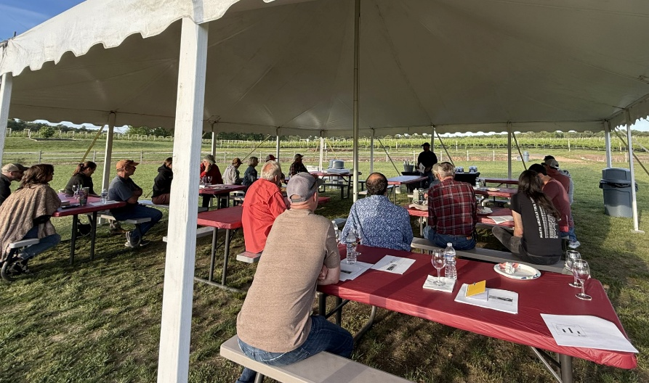

A total of 32 wine grape growers attended the May 20 **South Jersey Wine Grape Twilight Meeting** at Autumn Lake Winery in Williamstown, NJ. The twilight meetings provide timely information to wine grape growers on seasonal pest management and production-related issues, and pesticide regulation updates. The meeting also offers an opportunity for growers to ask questions and to bring their pest-damaged samples for symptom identification. The topics that were covered and their presenters included: Field Observations from the Wine Grape IPM Pilot Program - **Janine Spies,** Statewide Fruit IPM Program Leader; 2025 Recommendations for Disease Management - **Peter Oudemans**, extension specialist in small fruit pathology; Record Keeping Update for 2025 - **George Hamilton**, extension specialist in pest management; Grape Berry Moth in the Vineyard - **Anne Nielsen**, extension specialist in fruit entomology; Crown Gall – Early Symptoms and Management - **Hemant Gohil,** agricultural agent, RCE of Gloucester County; and Grape Nutrition Update - **Gary Pavlis,** agricultural agent, RCE of Atlantic County.

Participants at the South Jersey Grape Twilight Meeting.

# Collaborative Coastal Stewardship Event The annual “Coastal Stewardship Course,” part of our Barnegat Bay Shellfish Restoration Program and collaborations with ReClam the Bay, got under way on May 27. The course features 26 different presenters who will teach about issues related to the stewardship of our coastal marine resources, with Barnegat Bay ecology and shellfish restoration and aquaculture as the primary teaching tools. Ten weekly classes that are designed to teach participants how to get involved with local efforts to improve the health of our coastal ecosystems will come to a close on July 29. The Barnegat Bay Shellfish Restoration Program is a part of Rutgers Cooperative Extension and the New Jersey Agricultural Experiment Station, in partnership with ReClam the Bay, the New Jersey Department of Environmental Protection’ Division of Fish and Wildlife’s Bureau of Shellfisheries, and several local partners.

*Rutgers New Jersey Agricultural Experiment Station is an equal opportunity program provider and employer.*