September 2025

Carey Williams Named Interim Director of Rutgers Equine Science Center

Effective September 1, Carey Williams, extension specialist and professor in the Department of Animal Sciences, was appointed Interim Director of the Rutgers Equine Science Center. William’s area of research is equine nutrition, with specific focus on how nutrition affects the performance of the equine athlete. As an extension specialist, Williams facilitates and coordinates educational programs for the equine industry in New Jesey, as well as programs in whole farm management.

Tomato Tasting Event Features 50-plus Tomato Varieties and Debuts “Scarlet Sunrise”
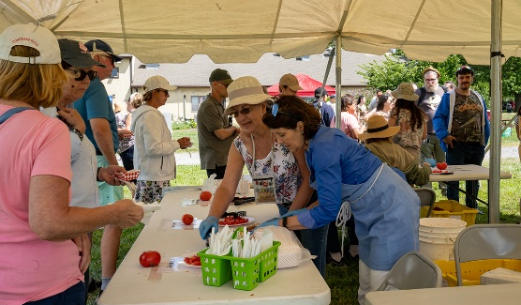
Rutgers Open House and Tomato Tasting was held on August 27 at the university’s Clifford E. and Melda C. Snyder Research and Extension Farm in Pittstown, N.J. More than 1,000 registered visitors sampled 50-plus varieties of tomatoes grown by Snyder Farm staff. New Jersey Spotlight featured a video of the event and the star “Scarlet Sunrise” bi-color grape tomato that made its big public debut. Developed through a decade-long collaboration between Rutgers researchers, Peter Nitzsche and Tom Orton, “Scarlet Sunrise” is a sweet, crack-resistant tomato with a golden hue and a reddish blush. The annual tasting event features wagon tours of the farm and stunning garden displays maintained by Rutgers Master Gardeners.
National Food Loss & Waste Consumer Education Campaign
Ohio State University and Rutgers Cooperative Extension (RCE) teamed up on a pilot for the USDA NIFA-funded Food Loss & Waste Consumer Education Campaign. RCE’s Department of Family and Community Health Sciences developed a “Consumer Food Waste Webinar Series” to provide a platform where individuals committed to reducing food waste could connect and share resources and solutions. The eight-month series, which ran from October 2024 to May 2025, attracted more than 900 attendees and featured 16 speakers. Held monthly, the online seminar series highlighted the efforts of Extension groups, university researchers, and other leaders in the food and sustainability industry, including the City of Denver and Washington State, who are making significant strides in combating consumer food waste. The success of the pilot has resulted in Year 2 programming to begin in fall 2025.
Spotlight on New Faculty Member Meli’sa Crawford

Meli’sa Crawford is a new faculty member in the Department of Animal Sciences. Her research focus is the gut microbiome and environmental exposures, with a particular interest in the intersection of human health and agricultural pollution from livestock and crop production. Crawford’s current research project explores how factors like air quality directly affect food systems and public health.

New Rutgers Patent for Sweet Basil Showing Increased Downy Mildew Resistance
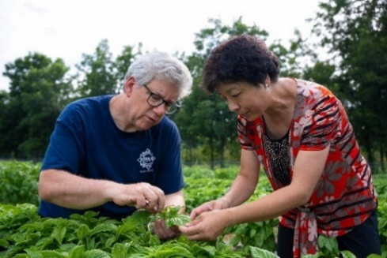
Downy mildew (DM) disease continues to be a worldwide threat to the basil industry despite the recent release of Rutgers DM- resistant varieties as the pathogen also continues to evolve. The Rutgers team has successfully modified the sweet basil DM-susceptible gene to generate DM-resistant mutant plants. Under greenhouse conditions, these mutant sweet basil plants displayed significantly improved resistance to DM. The team obtained the first-ever national USDA-APHIS (Animal and Plant Health Inspection Services) permit to field test the mutant sweet basil plants outdoors at Rutgers Horticulture Farm III. Two years in a row, these mutant sweet basil plants showed delayed DM disease onset and less severe symptoms, compared to non-edited plants, when exposed to severe disease conditions in the field. Gene-edited, transgene-free, DM resistant sweet basil plants are now being bred into the series of Rutgers DMR sweet basils in order to reduce the plants’ natural susceptible genes to disease while conserving the disease-resistant genes already bred into the sweet basils. This approach provides additional protection and will directly benefit farmers, consumers, and the environment by reducing the need for fungicide applications and its associated costs. This research, which is supported by USDA-NIFA, has resulted in a U.S. patent and publication of the findings.
Plant breeders Jim Simon and Rong Di

Research Study to Bolster Corn Crop Traits
Andrea Gallavotti, professor in the Department of Plant Biology and the Waksman Institute of Microbiology, is among a team of Rutgers researchers who have unlocked some of the secrets of corn DNA, revealing how specific sections of genetic material control vital traits such as plant architecture and pest resistance.

Recent Retirement
Karyn Malinowski, founding director of the Rutgers Equine Science Center (ESC), has retired after close to 50 years of service to Rutgers. Malinowski, who retired at the rank of professor in the Department of Animal Sciences, joined the faculty in 1978 as the first female Equine Extension Specialist in the U.S. Over the course of a long career at Rutgers, Malinowski has served in several leadership roles, including Associate Director of NJAES and Director of Rutgers Cooperative Extension.

Publications of Interest
The following fact sheets are available on NJAES Publications:
FS336: Soil Testing for Lead Contamination
Heckman, J. and Murphy, S.

FS1140: Incorporating Native Plants in Your Residential Landscape
Pinto, D. and Melendez, M.

FS1246: Spotted Wing Drosophila: A Key Pest of Small Fruits in New Jersey
Rodriguez-Saona, C., Nielsen, A., and Spies, J.

FS1374: Payment for Ecosystem Services and Climate Change
Kaplan, M.; Hu, A; Murphy, S.; and Robson, M.

FS1375: Sequestration of Carbon on Agricultural Lands
Kaplan, M.; Hu, A; Murphy, S.; and Robson, M.
Rutgers New Jersey Agricultural Experiment Station is an equal opportunity program provider and employer.

