October 2025

Showcasing Innovation and Collaboration Across NJ’s Agricultural Research Network
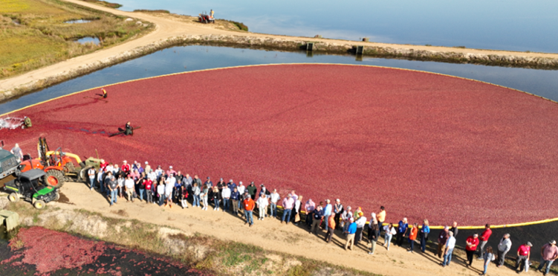
The New Jersey Agricultural Experiment Station (NJAES) hosted the 2025 Fall Meeting of the Research Center Administrators Society (RCAS)—a national organization dedicated to the professional development and collaboration of administrators who manage agricultural research and experiment stations across the United States. The meeting brought together approximately 80 attendees to explore the future of research management, collaboration and innovation in agriculture. The RCAS group toured NJAES’ statewide network of research and extension centers, highlighting the university’s broad contributions to agricultural advancement, sustainability and economic development in the Garden State.
Live cranberry harvest at Pine Island Cranberry Company

FCHS Brings Community Together Through Farmers Market Fall Festival
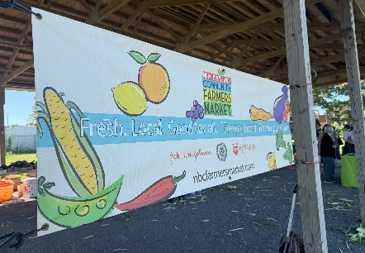
On October 18, Family and Community Health Sciences (FCHS) faculty and students hosted the Farmers Market Fall Festival at the Rutgers Community Farmers Market on Jones Avenue in New Brunswick. This festival transformed the weekly farmers market into a hub for civic learning and community dialogue, featuring hands-on activities that connect local agriculture to everyday life. Families took part in a Seed Democracy Workshop on food sovereignty, watched seasonal cooking demos by public health interns, and toured the garden co-op to learn about local food systems. This collaborative effort brought together Rutgers faculty, staff, students, and New Brunswick community members to strengthen university-community partnerships while promoting agricultural literacy, healthy eating, and community well-being—core tenets of New Jersey's land-grant mission.

Matthew Newman Appointed Chair of the Department of 4-H Youth Development

On July 1, Matthew Newman began a three-year term as Chair of the Department of 4-H Youth Development. He succeeded Rachel Lyons who served as chair for four terms. Newman previously served as 4-H agent and department head, Rutgers Cooperative Extension of Monmouth County. Among his priorities in his new role are greater visibility of 4-H youth programs at Rutgers and reinforcing the Rutgers connection to youth 4-H programs.

New RCE Program Focused on Reducing Farm Risks
Farm viability is a perennial concern of the agricultural community in New Jersey, and farm business management assistance has been identified as a critical area of need. Rutgers Cooperative Extension offers a new program, “Networks to Reduce Risk: Annie’s Project Builds Viable Farms in Urban and Rural NJ,” which aims to reduce overall farm business risk in the areas of market, production, financial, legal and human resources. Through a series of four field trips and six webinars, the program will connect urban and rural farmers to educational opportunities, resources, and each other. The field trips will focus on various aspects of risk management, including market diversification, value-added product development, cost-share program utilization, and farm safety enhancement. Locations include Urban Agriculture Cooperative Food Hub, Irvington, on Nov. 1; Rutgers Food Innovation Center, Bridgeton, on Nov. 19; Clover Valley Farm, Vincentown, on April 11; and Rutgers Snyder Research and Extension Farm, Pittstown, on April 28. Registration is open. For details, email anniesproject@njaes.rutgers.edu.

Research News
Using Drone Technology to Find Drought-Resistant Grass
Bingru Huang, Distinguished Professor in the Department of Plant Biology, is co-author of a new study using drones and advanced imaging technology to find out which types of zoysiagrass do best when water is scarce. Huang’s research team used drones equipped with special cameras to take detailed field-test pictures of Zoysiagrass, a popular lawn choice because it looks great and handles heat fairly well—but it still struggles in dry conditions. The images captured how the grass reflects different types of light, a clue to how healthy or stressed the plants are. Some grasses reflected light in ways that showed they were better at surviving without water. These grasses stayed greener and healthier during drought, especially compared to others that dried out quickly. Using this method, the team could pick out the best-performing types just by analyzing light patterns from the drone images.

What Bees Can Tell Us About Conservation and Land Use
Rachael Winfree, professor in the Department of Ecology, Evolution and Natural Resources, is the senior author of a new study that has challenged a long-held belief in ecology: that a bee’s body size determines how far it travels and, in turn, how much land around it matters. The study found that spring-flying bees are more likely to be associated with forests, while bees active in summer prefer open, sunny habitats like meadows or farmland. This pattern reflects where flowers bloom: forests bloom earlier in the year, while open spaces bloom later. The research has important takeaways for conservation and land-use planning as “ecologists often assume that larger animals need larger areas of habitat,” said Winfree, whereas the “findings show that we can’t make assumptions based on body size alone—we need to understand the natural history of the bee species. That’s how we’ll best protect pollinators and the ecosystems they support.” By improving our understanding of how wild pollinators interact with land use, it can inform public policies that support biodiversity, sustainable agriculture, and regional planning in areas like New Jersey and beyond.
New Publication
Available on NJAES Publications:
FS1376: Protect Those You Serve: Use Produce Safety Best Practices While Gleaning
Guidance for Gleaning Organizations
Melendez, M., Bihn, E., and Strawn, L.

Rutgers New Jersey Agricultural Experiment Station is an equal opportunity program provider and employer.

