November 2025

Environmental Stewards Celebrates 20th Anniversary
Rutgers Environmental Stewards Program, (RES) a certificate program that trains adult volunteers on important environmental issues in New Jersey in areas such as sustainable climate change solutions, storm water management, and habitat conservation marked its 20th anniversary this year. The milestone celebrated at the program’s annual Impact Summit on November 1 and showcased its projects and alumni and offered participants the opportunity to connect with statewide environmental leaders and organizations.

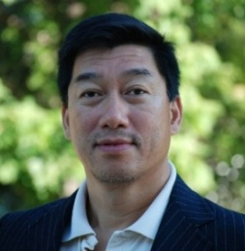
Distinguished Professor Eric Lam Wins Agriculture Innovation award
Eric Lam, Distinguished Professor in the Department of Plant Biology, received the Agriculture Innovation Award from Rutgers in recognition of researchers who have demonstrated “excellence by developing a breakthrough idea, process or technology that has shown its transformational potential to improve lives and create economic value.” In his 35-year career at Rutgers, Lam has worked to translate fundamental plant biology research into sustainable solutions for crop protection.
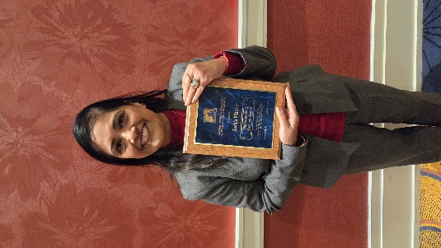
FCHS Educator Honored with 2025 Distinguished Service Award
Rutgers Family and Community Health Sciences Extension Educator (FCHS) Shailja Mathur was recognized by the National Extension Association of Family and Consumer Sciences (NEAFCS) with its 2025 Distinguished Service Award, the association’s highest honor for members who demonstrate exceptional leadership, outstanding educational programming, and significant professional development contributions to the field of Family and Consumer Sciences Extension.

New Jersey 4-H Youth Selected for Inaugural Leadership Academy in D.C.
Five New Jersey teens traveled to Washington D.C. to participate in a national 4-H Leadership Academy, a new program that aims to develop young leaders into lifelong problem solvers passionate about tackling society’s biggest challenges. In NJ, 4-H Youth Development is a department of Rutgers Cooperative Extension, with faculty and staff housed in each of New Jersey’s 21 counties, delivering the evidence-backed, research-based science from the university to families throughout the Garden State.

New Hire
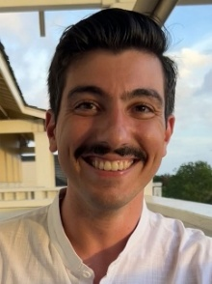
Michael Acquafredda is the new Assistant Extension Specialist in Aquaculture serving New Jersey. His research focuses on both the long-term issues that have historically affected New Jersey's aquaculture harvests and the more emergent problems that arise, often brought to attention by the local aquaculture industry stakeholders with whom he engages. These partnerships are vital to his role as he works to promote the industry adoption of novel techniques developed and supported by the Rutgers Coastal Campus.

Research News
Blast Them: A Rutgers Scientist Uses Lasers to Kill Weeds
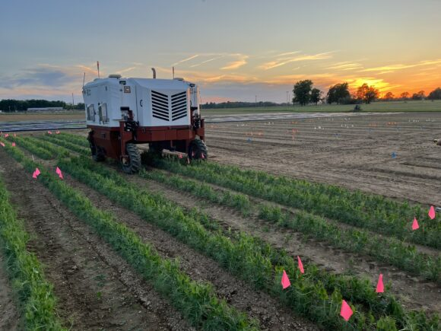
Thierry Besançon, associate professor in the Department of Plant Biology, recently collaborated on field trials of a tractor-size machine that can tell the difference between a vegetable and a weed – and then zaps the unwelcome plant with a laser. This high-tech device uses artificial intelligence and lasers to kill weeds without using chemicals. Results of the field tests, conducted as the first peer-reviewed study of artificial intelligence-guided laser weeding on the East Coast, were published in the research journal, Pest Management Science.

Keeping Oyster and Clam Farms Safe from Disease
David Bushek, professor in the Department of Marine and Coastal Sciences and director of the Haskin Shellfish Research Laboratory, is a co-author on a new study in Aquaculture that looked at how tiny oysters and clams (called seed) can carry diseases when moved between hatcheries and farms. The authors wanted to find out which life stages are most at risk and how careful water treatment can help protect both farmed and wild shellfish. The study analyzed data from more than 75,000 shellfish sampled over nearly 30 years and found that young shellfish raised in clean, treated water rarely carried harmful pathogens, but bigger, older oysters grown in untreated water had higher chances of carrying a disease called perkinsosis or dermo. Hard clams showed lower risk overall for all diseases studied.

Awards
Cesar Rodriguez-Saona, extension specialist in blueberry and cranberry entomology, has been recognized with the Entomology Society of America (ESA)’s Award for Excellence in Integrated Pest Management. This professional award, which is sponsored by Syngenta Crop Protection, recognizes outstanding contributions that have a direct relation to integrated pest management.
Maria Cramer, senior program coordinator for the vegetable IPM program, was recognized with the John Henry Comstock Award for the Eastern Branch of ESA. The John Henry Comstock Award is one of six awards given to a graduate student from each ESA Branch to promote interest in entomology and to stimulate interest in attending the ESA Annual Meeting.

GRANTS
Kit Yam, professor in the Department of Food Science, is co-principal investigator of the project, “Development of Sustainable and Active Packaging to Extend Shelf Life of Fresh Produce,” a USDA Small Business Innovation Research Phase I Project which was funded at $175,000. Principal investigator is Nazir Mir of MirTech.

New NJAES Publications Available
FS1376: Protect Those You Serve: Use Produce Safety Best Practices While Gleaning
Melendez, M., Bihn, E., and Strawn, L.
FS1377: Start Safe, Stay Safe: Produce Safety Made Simple for New Growers
Matthews, J. and Melendez, M.

Rutgers New Jersey Agricultural Experiment Station is an equal opportunity program provider and employer.

