December 2025

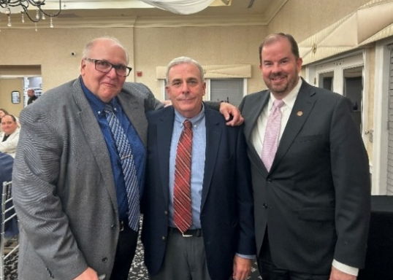
William “Bill” Bamka Recognized with “Distinguished Service Award”
William “Bill” Bamka, agriculture and natural resources (ANR) agent, RCE of Burlington County, was recognized at the Burlington County Board of Agriculture (BOA) dinner with the board’s “Distinguished Service Award.” Cranberry farmer and Burlington County BOA member, Bill Cutts, paid tribute to Bamka’s accomplishments and had this to say. “I’ve worked with Bill on various issues over many years. I’ve always found his advice to be sound, his help to be invaluable, and his work ethic to be extraordinary. I believe that those of you who have worked with Bill have found the same things. He is the epitome of what an agricultural agent should be, and how they should conduct themselves to better the agricultural industry.”
L-R: Paul Hlubik, Burlington County farmer and ag leader; William “Bill” Bamka and Brian Schilling, director, RCE.

RCE Professionals Recognized with National 4-H Awards and Hall of Fame Induction
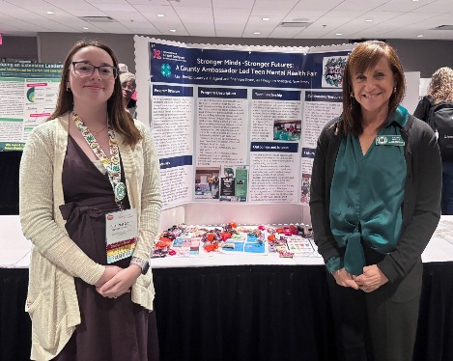
Five Extension professionals with the 4-H Department of Youth Development were recognized by the National Association of Extension 4-H Youth Development Professionals. Melissa Bright, 4-H agent, RCE of Somerset County – Achievement in Service Award; Kelly Dziak, 4-H agent, RCE of Morris County – Distinguished Service Award; Alayne Torretta, 4-H agent and department head, RCE of Warren County – 25 Years of Service Award; and Laura Bovitz, 4-H agent, and Shannon Glynn, 4-H program assistant, RCE of Middlesex County – National Award for Excellence in Healthy Living Programming for their work in the Teen Mental Health Fair. Jeannette Rea Keywood, state 4-H agent at the time of her passing, was posthumously inducted into the National 4-H Hall of Fame.
Shannon Glynn and Laura Bovitz, RCE of Middlesex County, present the poster of their award-winning program at the 4-H conference.

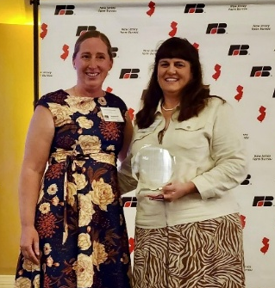
Michelle Infante-Casella Named “Woman of the Year” by NJ Farm Bureau
Michelle Infante-Casella, agricultural agent and department head, RCE of Gloucester County, was recognized as a “Woman of the Year” by the New Jersey Farm Bureau’s Women’s Leadership Committee (WLC) on November 17. Infante-Casella also received a New Jersey Legislative Joint Commendation from Senator John Burzichelli, Assemblyman David Bailey, and Assemblywoman Heather Simmons. Infante-Casella is the first woman to achieve the title of County Agent I, in the RCE Department of Agriculture and Natural Resources (ANR), and is only one of five faculty currently in ANR to achieve this rank.
At left, Danielle Wainwright, WLC chair, NJFB, and Michelle Infante-Casella.

Plant Biologist James Simon Elected to the National Academy of Inventors
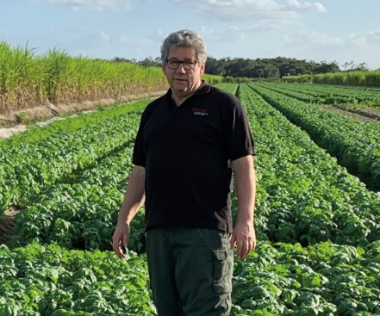
James Simon, Distinguished Professor in the Department of Plant Biology, received the highest honor for his work with his election to the National Academy of Inventors. With the threat of the downy mildew wiping out basil production in the U.S., Simon and team spent more than a decade identifying the pathogen, developing a solution and breeding the first downy-mildew-resistant basil varieties that are now grown worldwide. He is one of 169 U.S. inventors elected to the 2025 Class of Fellows and the 14th Rutgers professor to be named and elected to the prestigious organization.
Delma Yorimoto, FCHS educator, recently presented at the 4th Annual People of Color Living with Diabetes Summit, a hybrid event focused on bringing together community leaders and healthcare professionals to provide education and discussion on mental health issues related to diabetes, diabetes technology, health equity, and health services for communities impacted by diabetes.

JOINING RCE

The Department of Family and Community Health Sciences (FCHS) welcomed Erin Comollo as an Assistant Professor of Teaching. In this role, she supports the FCHS undergraduate minors, Health Equity and Holistic Wellness, manage our experiential learning internships, and lead special projects such as the New Jersey Healthy Communities Network and the FCHS programming at Healthy Harvest.

RETIREMENT
Bill Hlubik, agriculture and natural resources agent and RCE department head for Middlesex County, retired on December 1. He’s received more than 100 national, regional and state awards for programs and research over the course of his 36 years at Rutgers. He was the co-researcher and developer of the patented Rutgers Scarlet strawberry and helped to create RU Ready to Farm™, a “beginner farmer” training program for people new to farming to address two related challenges: the aging of New Jersey farmers and the inexperience of many drawn to the profession

RESEARCH
Ximing Guo, Distinguished Professor in the Department of Marine and Coastal Sciences, is co-author of a recent study that unlocked the complete genetic code of a special hybrid oyster, providing a valuable tool that could help improve how these shellfish are farmed.

Bingru Huang, Distinguished Professor in the Department of Plant Biology, is co-author of a recent research study reviewing how different types of stress—like brief exposure to heat, drought, or cold—can prepare plants to survive extreme heat later on.

Available on NJAES Publications:
FS593: Woodlot Management: Working Safely in the Woods
Alabastro, R. and Dvorin, R.
FS1378: Tips for Supporting Barn Swallow Colonies on Your Property
Maslo, B., McHale, E., and Kerwin, K.

Rutgers New Jersey Agricultural Experiment Station is an equal opportunity program provider and employer.

