February 2026

Rutgers Showcases Research and Expertise at 2026 Ag Convention
In partnership with the Vegetable Growers Association of New Jersey, NJAES’ Rutgers Cooperative Extension (RCE) helped deliver one of the region’s most comprehensive agricultural education programs at the 2026 Northeast Agricultural Expo—reinforcing the university’s impact on farm viability and the state’s agricultural economy. RCE agricultural agents Michelle Infante-Casella (Gloucester County) and William Bamka (Burlington County) co-chaired the wide-ranging Rutgers educational program, coordinating 82 presenters across three days of workshops and concurrent sessions. The event drew a sold-out trade show floor and strong statewide participation from farmers, agricultural professionals, 4-H and FFA students, and industry partners.

Rutgers 4-H at the NASDAQ Bell Ringing
Last December, five New Jersey 4-H Agriculture Ambassadors Lead to Change Project grant winners joined Tractor Supply Company and National 4-H Council at the NASDAQ opening bell-ringing ceremony in Times Square, New York. This occasion celebrated the long-standing partnership between Tractor Supply Company and 4-H and highlighted their shared commitment to investing in the next generation of agricultural leaders. During the event, the New Jersey 4-H Agriculture Ambassadors joined fellow 4-H youth from New York, Connecticut, and Kentucky. Melissa Bright, 4-H agent (Somerset County) and Amelia Minervini, 4-H senior program coordinator (Ocean County), attended to support the 4-H youth.

FCHS Staff Presents on Collaborative Food Waste Reduction Program
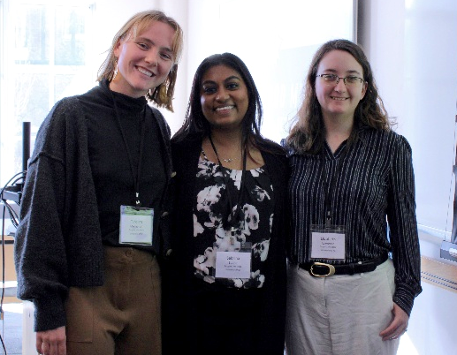
Sabrina Subhit, senior program coordinator, Department of Family and Community Health Sciences (FCHS), presented at the Alliance for New Jersey Environment Education (ANJEE) 41st Annual Winter Conference alongside AmeriCorps members Elizabeth Lawrence and Caroline Monaghan on January 16. Their presentation focused on the “Guardians of the Food Galaxy” program, which encourages fifth-grade students and their educators to become protectors of the planet by merging environmental education with food waste reduction initiatives. RCE collaborates with AmeriCorps to bring this program to elementary schools across the state. Attendees left with the knowledge and resources needed to implement this empowering educational program in their schools.
FCHS’ Sabrina Subhit (center) with Americorps members Caroline Monaghan, at left, and Elizabeth Lawrence, at right.

RCE of Atlantic County Welcomes New Faculty
Patrick McMullen, joins the Atlantic County office of Rutgers Cooperative Extension (RCE) from Cornell University, where he recently completed a doctoral degree focused on soilborne pathogen management and healthy crop establishment. His outreach and extension practice will focus on sustainable commercial vegetable production.

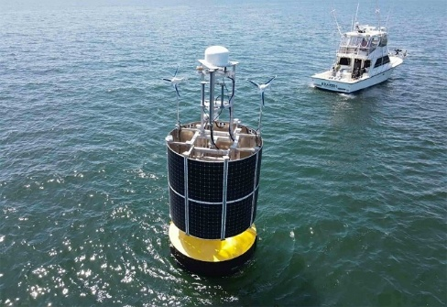
Rutgers and Partners Restart a Pioneering Marine Observatory
Rutgers University and Stockton University have partnered with the New Jersey Economic Development Authority and Ocean Power Technologies Inc. to relaunch a pioneering marine observatory off the Jersey Shore, revitalizing the historic Long-Term Ecosystem Observatory (LEO) site as a hub for ocean research, innovation, and workforce development. Central to the effort is the deployment of a PowerBuoy® research platform in early 2026 near the Rutgers Marine Field Station in Tuckerton, which will provide real-time ocean data and infrastructure for scientific instruments, education, and technology testing. According to Josh Kohut, marine scientist and NJAES director of research, “the PowerBuoy® is set to usher in a new era of partnership in marine and coastal research in New Jersey…and will be a critical element in strengthening our ability to observe, understand, and respond to changes along our coast.”
PowerBuoy®. Courtesy of Ocean Power Technologies Inc.

AWARDS
Corday Selden, assistant professor in the Department of Marine and Coastal Sciences, received The Oceanography Society (TOS) Early Career Award, which recognizes outstanding early-career research, leadership in ocean sciences, and exceptional promise for future impact in oceanography.

Allyson Salisbury, assistant teaching professor in the Department of Ecology, Evolution, and Natural Resources, received the International Society of Arboriculture Early-Career Scientist Award, which recognizes exceptional promise, with high potential to become an internationally recognized scientist.

John Wilkin, professor, and Hernan Arango, research programmer, in the Department of Marine and Coastal Sciences, along with Andrew Moore, professor at University of California-Santa Cruz, were honored by the American Geophysical Union (AGU) with its 2025 Edward A. Flinn III Award, a coveted AGU honor for mid-career or senior scientists who build and maintain the essential infrastructure that allows Earth and space science research to flourish.

RETIREMENT
Carl Pray, Distinguished Professor in the Department of Agricultural, Food, and Resource Economics, retired from Rutgers, concluding a remarkable 40-year career defined by scholarship, global engagement and service for the greater good. Pray has made pathbreaking contributions to agricultural science and technology policy, with research spanning Asia, Africa, and Latin America.

FACTSHEETS ON NJAES PUBLICATIONS
FS1356: 2026 Vegetable Integrated Pest Management Delivery Program
Quadrel, A. and Cramer, M.
FS1380: Introduction to Community Food Systems
Urdanivia, C.; Bromfeld, G.; Kairios, R.; and Zelkowicz, M.
FS1381: Ag Labor in New Jersey
Lee, S.

FS1382: Empowering the Next Generation: Engaging Teens in Food Systems Education
Kairios, R.; Urdanivia, C.; Bromfeld, G.; Patel, P. and Zelkowicz, M.

FS1388: Soil Testing for Certified Organic Recommendations
Heckman, J.

Rutgers New Jersey Agricultural Experiment Station is an equal opportunity program provider and employer.

