March 2026

Rutgers Cooperative Extension Hosts Annual Conference
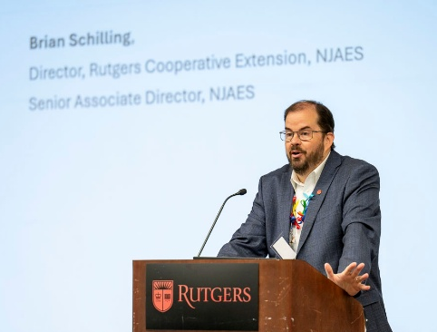
The 2026 Rutgers Cooperative Extension (RCE) Annual Conference, which convened on January 15, brought together faculty, staff, and statewide stakeholders for a day of networking, professional development, research collaboration, and the exchange of best practices in delivering research-based educational programming. RCE Director Brian Schilling reflected on a year defined by progress, pointing to growing partnerships, increased visibility across the university, and expanding recognition of RCE’s essential role in research translation and community engagement. In delivering the Executive Leadership Address, Laura Lawson, Executive Director, NJAES, reflected on the strategic priorities of RCE, reaffirming its leadership in advancing science-based solutions, strengthening partnerships, and expanding statewide impact.

Rutgers Co-Sponsors Regional Conference on AI Tools for Agriculture
The 2026 AI and Farm Viability Roundtable, the second annual Farm-to-Roundtable conference, was held at Camden County College on February 20, 2026. The event brought together farmers, researchers and agricultural stakeholders from across New Jersey and the Northeast to explore emerging applications of artificial intelligence in agriculture. Co-sponsored by the New Jersey Big Data Alliance, Rutgers University, Rowan University and Camden County College, the conference featured workshops and discussions focused on how AI technologies can support farm efficiency, resilience, and long-term viability. Rutgers was well represented among the presenters and moderators, including keynote speaker Brian Schilling, director of Rutgers Cooperative Extension; lightning talks moderator Peter Oudemans, director of the Philip E. Marucci Center for Blueberry and Cranberry Research and Extension; presenters Juan Gonzalez, postdoctoral research associate; Gina Sideli, assistant professor, Marucci center; and Janine Spies, statewide program leader and county agent in Fruit Integrated Pest Management. Additional Rutgers participants included Josh Kohut, director of research at NJAES, who moderated a breakout session and a panel discussion, and Kristin Dana, professor in the Department of Electrical and Computer Engineering, who moderated a second panel discussion.


FCHS and 4-H Collaborate on Impactful, Hands-on Cooking Experience
The departments of Family and Community Health Sciences (FCHS) and 4-H Youth Development teamed up in Passaic County for a hands-on cooking experience that left a real impact. On February 21, FCHS educator Jennifer Taylor joined the Passaic County 4-H Junior/Teen Council in the teaching kitchen at the RCE office of Passaic County, where the youth learned to make flavorful turkey tacos from scratch. After the workshop, 75% of participants went home and cooked dinner for their families, a meaningful milestone since none of the youth had ever prepared a full meal without adult assistance. This collaboration not only built cooking confidence but also sparked pride, independence, and healthier habits among young people.

New Workshop Series Helps Faculty Expand Their Research Vision
The SEBS Office of Research launched a new initiative to help faculty in the School of Environmental and Biological Sciences and NJAES reflect on their research career path, identify funding opportunities, and adapt to shifting research priorities. At the end of the six-week series, which kicked off in January 2026, the goal is for faculty to team up across departments and disciplines to craft transdisciplinary-focused concept papers they will then use to pursue critical areas of research.

Retirement
George Hamilton
Effective January 1, George Hamilton, extension specialist in pest management and professor in the Department of Entomology, retired from Rutgers University, concluding a distinguished 38-year career marked by excellence in extension, research, teaching, and service to the university and the agricultural community. Hamilton’s decades of service have had a lasting impact on Rutgers, New Jersey agriculture and the field of pest management.

Award
George Carman, Board of Governors Professor of Food Science, Distinguished Professor and founding director of the Rutgers Center for Lipid Research at the New Jersey Institute for Food, Nutrition, and Health, was awarded the American Society for Biochemistry and Molecular Biology’s Herbert Tabor Research Award for his outstanding accomplishments and contributions to the scientific community.

Grants
Christopher Obropta, extension specialist in the Department of Environmental Sciences and director of the New Jersey Water Resources Research Institute, received a one-year award of $146,052 from the US Geological Survey for the New Jersey Water Resources Research Institute FY2025 104(b) Program. The award period runs from 1/29/2026 to 1/28/2027.

Hemant Gohil, agricultural agent, Gloucester County, was awarded $10,000 by the New Jersey Peach Promotion Council to continue evaluating new, standard, and advanced selections of peach varieties.

FACTSHEETS ON NJAES PUBLICATIONS
REVISED: FS1124: Vegetable Disease Recommendations for Home Gardens
Wyenandt, A. and Nitzsche, P.

FS1140: Incorporating Native Plants in Your Residential Landscape
Epiphan, J. and Melendez, M.

NEW: FS1391: Deer Damage Control in the Vineyard
Gohil, H., Ward, D. and Guikima, A.

Events
Auditor’s Workshop: Managing Environmental Compliance, to be held from May 11 to 17. Learn the basics of auditing as well as updated regulations, tools, and resources from NJDEP and industry presenters in this weeklong online course designed to help business remain in compliance. Register by May 7. Learn more at https://cpe.rutgers.edu/environmental/auditors-workshop-environmental-compliance or contact Pamela Springard-Mayer, Rutgers NJAES Office of Continuing Professional Education, via email at pspring@rutgers.edu.

Rutgers New Jersey Agricultural Experiment Station is an equal opportunity program provider and employer.

