April 2026

Snyder Farm Honored by New Jersey Agricultural Society
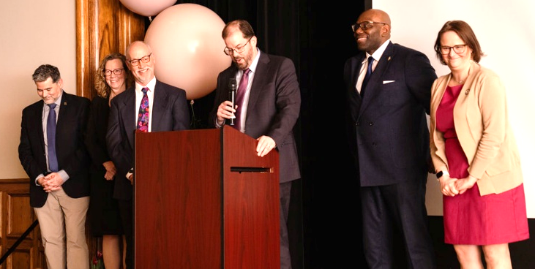
Ed Dager and the Clifford and Melda C Snyder Research and Extension Farm in Pittstown, NJ, won the 2026 Neil Robson Farmers Against Hunger Award, which is presented by the New Jersey Agricultural Society to honor those who make outstanding contributions to the fight against hunger by providing fresh vegetables to those who need them. Snyder Farm has donated tens of thousands of pounds of produce to Farmers Against Hunger. Dager and the Snyder Farm team were recognized for their efforts in the fight against food insecurity in New Jersey.
L-R: Josh Kohut, NJAES director of research; Laura Lawson, NJAES executive director; Peter Nitzsche, director of Snyder Farm; and RCE director Brian Schilling at the podium; NJ Senator Troy Singleton; and NJ Assemblywoman Andrea Katz.
New Jersey Farm and Fisher Wellness Forum
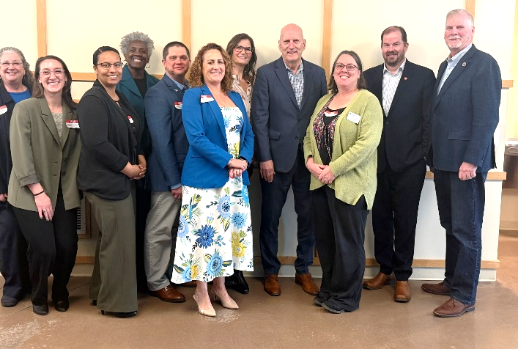
On March 19 at the Rutgers Eco-Complex, a team of Rutgers Cooperative Extension (RCE) and Rutgers faculty and staff hosted the “New Jersey Farm and Fisher Wellness Forum - Connecting for Health and Vitality” that brought together leaders from across NJ in the farm, fisher, and aquaculture industries, along with professionals from prevention services, health insurance, healthcare, mental health, Department of Agriculture, Department of Health (DOH), and other related sectors. The strength of the forum came from the wide range of professionals who participated. Their shared expertise during the Strategic Doing™ activities helped build a stronger network to support the farm and fishing industries, and the group identified several immediate steps to begin advancing this work. Secretary of Agriculture Ed Wengryn, Board of Agriculture President Allen Carter, and Rutgers Cooperative Extension Director Brian Schilling joined the forum in support of this effort. Nashon Hornsby, assistant commissioner, DOH, also attended along with additional agriculture and fisher industry leaders.
L-R: New Jersey Farm and Fisher Wellness Forum planning committee members: Maria Pippidis (University of Delaware Extension) and RCE personnel Annalise VanVranken, Kate Brown, Patty Omehke, Doug Zemeckis, Chris Zellers, Rachel Tansey, Jen Sawyer Carabello, and RCE Director Brian Schilling. Missing committee members: Peggy Swarbrick and Jamey Lister. Also pictured are Secretary of Agriculture Ed Wengryn (fourth from right) and Farm Bureau President Allen Carter (at right).

Haskin Lab Strengthens Oyster Industry Through Research and Collaboration
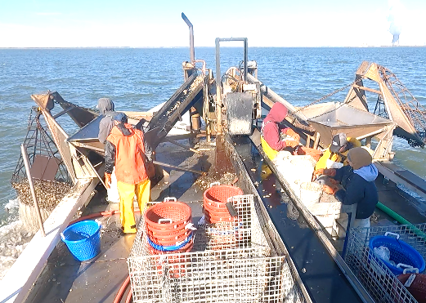
The Haskin Shellfish Research Laboratory has been working collaboratively with the Delaware Bay Oyster Industry and the NJDEP Division of Fish and Wildlife since 1953 when the industry requested assistance to determine the cause of a declining oyster resource. Since then, the Haskin Lab—as part of Rutgers NJAES— has conducted annual surveys of the population to help manage the Delaware Bay oyster resource and support a sustainable harvest. Over the years, and with external expert review that includes NJDEP and active oyster fishermen, the lab has led the development of a sustainable oyster fishery that is a leading example for the region and beyond. This sustainable fishery relies on a ‘total allowable catch,’ which differentiates it from most other shellfisheries that attempt to use license limits or limits on duration of the harvest season to control fishing. Haskin Lab hosted the 2026 Annual Delaware Bay Stock Assessment Workshop on February 4 and 5, 2026, and presented harvest recommendations to the Shellfisheries Council on March 3. The council approved a potential harvest of 79,866 bushels. This requires the industry to work with NJDEP to complete several enhancement activities that help ensure recovery of the fished population. The oyster industry is a vital resource in rural areas of southern New Jersey and represents a significant economic boost to an impoverished region of the state.
Haskin Lab scientists performing oyster stock assessment.

35th Annual Turfgrass Symposium
Rutgers Center for Turfgrass Science hosted its 35th Annual Turfgrass Symposium on March 19, bringing together faculty, staff, students, researchers and industry leaders for a day of collaboration, innovation, and knowledge exchange. The symposium highlighted the breadth of turfgrass research underway across the university while reinforcing Rutgers’ leadership in advancing sustainable turf systems. The daylong showcase of research highlighted the importance of interdisciplinary collaboration in addressing emerging environmental and industry challenges.

Grape Expectations 2026
The New Jersey Wine and Grape Symposium sponsored by NJAES, the New Jersey Department of Agriculture, and the Garden State Winegrowers Association, was held on March 12. The annual symposium—the 46th in the daylong series of lectures on viticulture (grape growing), enology (wine making) and marketing—addresses the challenges of growing grapes in the Mid-Atlantic region. Presentations from current Extension faculty and industry professionals offered the current information relevant to both professionals and amateurs involved with any aspect of grape growing or the wine industry. Co-organizers included Daniel Ward, associate extension specialist in pomology, and RCE agricultural agents Gary Pavlis (Cape May County) and Hemant Gohil (Gloucester).

FACTSHEETS ON NJAES PUBLICATIONS
FS232: Diamondback Moths in the Home Garden
Fisher, B. and Carll, R.
FS759: Care for the Older Horse: Diet and Health (Rutgers NJAES)
Williams, C. and Herbst, A.
FS1123: Vegetable Insect Control Recommendations for Home Gardens
Nitzsche, P. and Ghidiu, G.
Rutgers New Jersey Agricultural Experiment Station is an equal opportunity program provider and employer.

