May 2026

CELEBRATING EXCELLENCE AT SEBS 2026 CONVOCATION
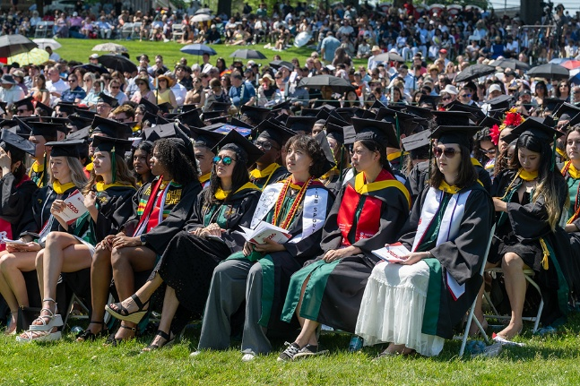
Despite 90-degree temperatures, the Convocation of the School of Environmental and Biological Sciences (SEBS) was proudly celebrated on the lawn of the historic Passion Puddle on May 18. The ceremony honored the remarkable achievements of the SEBS Class of 2026, including 14 graduates who earned a perfect 4.0 cumulative grade point average. An additional 57 students graduated summa cum laude, achieving GPAs between 3.85 and 4.0, and demonstrating impressive academic achievement. Among the 721 SEBS graduates celebrated this year, nearly one quarter (23%) were first-generation college graduates, reflecting the school’s ongoing commitment to academic excellence, opportunity, and student success.

FCHS Webinar on Emerging Challenges of Bots and AI in Research Data Collection
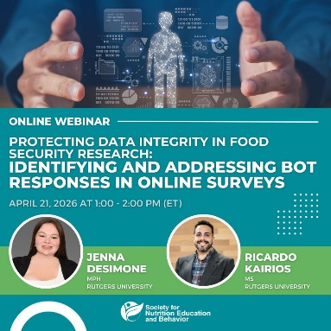
As technology continues to reshape research and data collection practices, automated bots and artificial intelligence (AI) emerged as growing challenges to maintaining data integrity and accuracy. On April 21, the Department of Family and Community Health Sciences (FCHS) co-hosted a webinar examining how automated survey responses can distort findings, misrepresent public opinion, and influence policy and programmatic decisions. Drawing from a statewide New Jersey study in which bot activity significantly affected preliminary results, presenters shared real-world examples of the risks posed by invalid responses in research settings. The session also highlighted practical strategies for identifying bot-driven patterns, reducing bias, and strengthening the reliability of collected data. Attendees gained valuable insights into balancing technological innovation with ethical research practices, particularly in relation to community nutrition programs and other public-facing initiatives that rely on accurate, representative data.

4-H Program Explored Futures in Agriculture & STEM
The Department of 4-H Youth Development launched the Advancing Careers in Agriculture and STEM (ACAS) Teen Agri-Science Internship Program this year, providing high school youth with hands-on opportunities to explore education and career pathways in agriculture and STEM. Managed through the Passaic County office and open to youth statewide, the inaugural program was designed to engage students with limited prior exposure to these fields, remove barriers to participation, and connect new communities with 4-H and Rutgers Cooperative Extension. Participants traveled across New Jersey to visit farms, industry partners, community colleges, and Rutgers University, gaining real-world insight into higher education and the workplace. Workshops focused on resilience, life skills, and workforce readiness further help students build confidence for future success. Recruitment for the 2026 cohort is now underway, inviting more youth to explore emerging opportunities in agriculture and STEM.

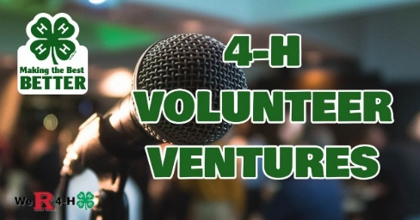
4-H Podcast Expands Training and Support Reach Nationwide
A podcast developed to support 4-H volunteers and families continued to grow its audience and impact through accessible, conversational episodes focused on key aspects of the 4-H program. Designed as an ongoing professional development and engagement resource by the Department of 4-H Youth Development, the podcast featured short-form episodes that provided practical guidance, program insights, and volunteer support in an approachable format. To date, more than 50 episodes have been released on Spotify and other major streaming platforms, with new episodes continuing to launch on a bi-weekly schedule. Collectively, episodes have been downloaded and streamed more than 2,220 times, demonstrating sustained interest and engagement among listeners. Listeners from 44 states spanning every region of the country accounted for 43% of the U.S. audience, reflecting the podcast’s growing national reach. The podcast has also gained strong support from Extension professionals beyond New Jersey. Volunteer Specialists in Maine, New Hampshire, and New York have actively promoted the resource to volunteers and 4-H staff through regular statewide communications, further expanding its visibility and use as a training and support tool.

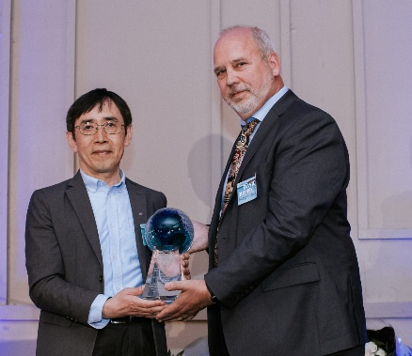
Ximing Guo Receives Prestigious 2026 Samuel S. Baxter Memorial Award
Ximing Guo, Distinguished Professor in the Department of Marine and Coastal Sciences, has been honored by the Water Resources Association of the Delaware River Basin (WRA) with its 2026 Samuel S. Baxter Memorial Award. The award recognizes individuals who best exemplify WRA’s mission through contributions to sound water management. A renowned shellfish geneticist based at the Haskin Shellfish Research Laboratory, Guo has focused on understanding the genetics of shellfish populations and their cultivation in Delaware Bay and beyond. He was recognized by WRA on April 23 for his transformative research, which has reshaped global aquaculture and strengthened the resilience of the Delaware Bay.
Ximing Guo pictured with David Bushek, director of the Haskin Lab.

Grant to Build Hands-On Learning Pathways to Strengthen Food Security
A $50,000 convergence research seed grant (May 2026–April 2027), led by Erin Comollo (FCHS/Rutgers Cooperative Extension), Edrice Robinson-Wyatt (SEBS Office of Academic Programs), and Brian Kurisky (RU Collaborative Center for Community Engagement) will support the development of an interdisciplinary approach to strengthening New Jersey’s food security workforce. The project brings together personnel from Community and Family Health Sciences, Nutritional Sciences, Plant Biology, Human Ecology, and Experiential Learning Design, alongside community organizations and students, to create hands-on learning opportunities that connect nutrition, agriculture, public health, and community development. Grounded in the Rutgers Healthy Harvest Initiative and the NJ Healthy Communities Network community partnerships, the model is designed for local implementation and potential replication at peer land-grant institutions nationwide.

Rutgers New Jersey Agricultural Experiment Station is an equal opportunity program provider and employer.

