June 2026
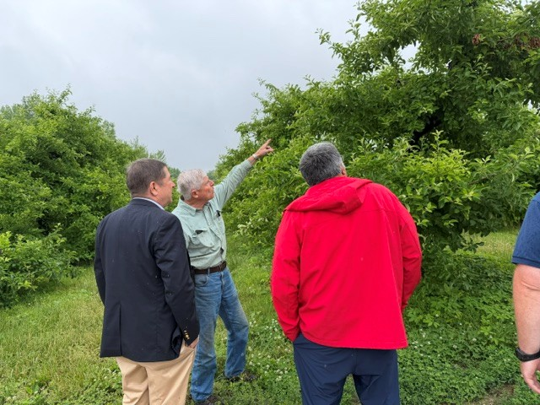
USDA, Rutgers Address Freeze Impacts on NJ Fruit Growers
USDA Farm Service Agency (FSA) national and state leaders met with growers, agricultural organizations, and Rutgers Cooperative Extension (RCE) at Summit City Farms in Glassboro on May 27 to assess the impact of April's devastating freeze on New Jersey fruit crops. FSA Administrator William Beam discussed federal disaster assistance efforts and available support programs for affected farmers. The meeting included a tour of frost-damaged apple and peach orchards. Later that day, Hemant Gohil, RCE agricultural agent in Gloucester County, organized the South Jersey Fruit Twilight Meeting, which focused on production challenges resulting from freeze damage. Rutgers presenters at the twilight meeting included Brian Schilling, Nancy Sharma, Ann Nielsen, Janine Spies, Thierry Besancon, and Katrina Dewitt provided growers with practical recommendations for weed, disease, and pest management during a challenging production season.
FSA administrator William Beam (left) inspects tree fruit at Summit City Farms.
Educator-Community Climate Resilience Initiative Launched
The Department of 4-H Youth Development and the Jacques Cousteau National Estuarine Research Reserve are collaborating on a multi-year project that brings together New Jersey educators, students, and community partners to advance climate resilience efforts. Through Resiliency Action Teams, youth will build a shared understanding of climate threats, informed by both scientific data and their own lived experiences. Using this knowledge, students will be supported in developing and implementing community-based solutions that address local challenges. The inaugural cohort includes six schools from the greater Newark and Jersey City areas. This effort is part of Building a Climate Ready NJ, a resilience initiative of the New Jersey Department of Environmental Protection funded by the National Oceanic and Atmospheric Administration, and helps prepare the next generation of leaders to address climate-related issues in their communities.

FCHS Educator Recognized for Excellence in Nutrition Education

Jennifer Salt Taylor, Family and Community Health Sciences Educator (FCHS), Passaic County, was named the 2026 Northeast Region Outstanding Preceptor by the Nutrition and Dietetic Educators and Preceptors (NDEP). The award recognizes her exceptional commitment to mentoring future nutrition professionals through experiential learning. Since joining RCE in 2023, Salt Taylor has served as a preceptor for 11 dietetic interns from Rutgers University and Montclair State University, providing more than 1,100 hours of supervised community nutrition training. Through her mentorship, interns gained hands-on experience applying evidence-based nutrition education and public health principles in community settings. Her recognition highlights RCE's important role in workforce development, professional education, and improving community health across New Jersey.

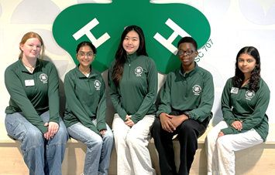
Rutgers 4-H Youth Gain National Leadership Experience
The Department of 4-H Youth Development supported five New Jersey 4-H members selected to participate in the national 4-H Leadership Academy, a two-year program designed to prepare youth to address community and societal challenges through leadership, civic engagement, and service. The students traveled to Washington, D.C., in May 2026 to join youth delegates from four other states for the program's inaugural leadership summit. During the three-day experience, participants engaged with national stakeholders, congressional 4-H alumni, and representatives from National 4-H Council while beginning coursework focused on critical thinking, communication, problem-solving, and civic leadership. Over the next two years, participants will identify local issues, conduct research, and collaborate with community leaders to develop and implement solutions that create meaningful impact. Coordinated in New Jersey by Kelly Dziak, 4-H agent, Morris County, the program reflects Rutgers 4-H's commitment to developing informed, engaged, and effective leaders who are prepared to strengthen their communities and contribute to a better future.

RU Research Ready? Preparing the Next Generation of Researchers
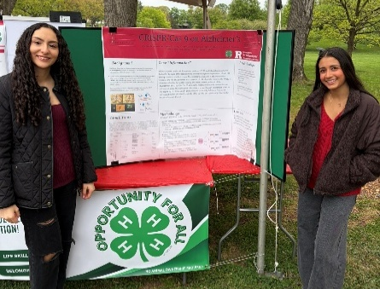
The Department of 4-H Youth Development of Hunterdon and Passaic counties partnered to pilot a combined Research Ready and Poultry Ambassadors program that introduced youth to the research process through a One Health framework. Conducted throughout the academic year in a hybrid format, participants developed skills in research design, source evaluation, data collection, and scientific communication. Youth engaged directly with Rutgers researchers through visits to the School of Environmental and Biological Sciences’ marine sciences and anthropology laboratories and virtual sessions with experts, including members of the New Jersey One Health Task Force. Participants investigated topics ranging from poultry health and predator prevention to artificial intelligence in medical diagnostics and urban soil conditions. The program culminated with youth presenting research posters and educational videos on Rutgers Day. The experience strengthened participants’ research skills, sparked interest in STEM careers, and created a pathway for returning students to mentor future cohorts. By giving youth the opportunity to directly engage in research, we can confidently answer the question: RU Research Ready?

Growing Community Wellness Through Gardening
Rutgers Cooperative Extension of Essex County expanded its Hope Village Garden Club in 2026, building on a successful inaugural year with an enhanced series of 12 workshops running from April through September. Led by Veronica Jones, FCHS educator, Essex County, in collaboration with Claudia Urdanivia, agricultural agent, Essex County, the program offers hands-on learning focused on gardening, nutrition, and wellness. New topics include native plants, microgreens, and wellness herbs, complemented by food demonstrations, tastings, and nutrition education. Supported by a $5,000 Family and Community Health Sciences Spark Mini-Grant, the initiative addresses important social determinants of health, including food security and housing stability. By increasing access to fresh, nutritious foods, strengthening gardening skills, and fostering community connections, the Hope Village Garden Club helps empower residents to make healthier choices while building a more resilient and connected community.

Rutgers New Jersey Agricultural Experiment Station is an equal opportunity program provider and employer.

