July 2026

Rutgers 4-H Hosts State Teen Leadership Conference

The Rutgers 4-H State Teen Leadership Conference welcomed 43 high school youth from 17 New Jersey counties to the Rutgers–New Brunswick campus for a weekend of leadership development, college readiness, and experiential learning. Hosted by the Department of 4-H Youth Development from June 26 to 28, the conference was designed to build a "bridge to Rutgers" and connected participants with university faculty, research, and academic programs through hands-on experiences in the Food Science, Marine and Coastal Sciences, and Engineering departments. Youth received an authentic introduction to the Rutgers student experience, research excellence, and the university's land-grant mission. Rutgers is committed to developing the next generation of leaders while strengthening the connection between New Jersey 4-H and the university through meaningful, research-based educational experiences.

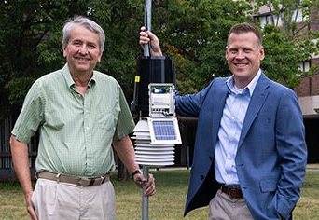
New Leadership in NJ State Climatologist Office Builds on 35-Year Legacy
In New Jersey, the Office of the State Climatologist was established at Rutgers’ Cook College, now the School of Environmental and Biological Sciences, in 1979 by then-Gov. Brendan Byrne to centralize climate expertise and activities across the state. Distinguished Professor David Robinson, New Jersey’s state climatologist since 1991 and the longest-serving state climatologist on record in the U.S., is retiring from the role after 35 years of public service. John Krasting, a Rutgers-trained climate scientist and longtime NOAA researcher, was named his successor, effective July 1. Krasting earned his bachelor’s degree in meteorology and Ph.D. in atmospheric science from Rutgers. His research has focused on climate risk, sea-level rise, coastal inundation, and Earth system modeling. A former broadcast meteorologist, he also brings experience communicating complex climate science to public audiences. In his new role as NJ State Climatologist, Krasting will continue to provide authoritative climate information and support research, education, and engagement with agencies, communities, and stakeholders statewide.
David Robinson, at left, pictured with John Krasting.
FCHS Program Helps Strengthen Food Security Through Family Education
The Department of Family and Community Health Sciences in Cape May County is supporting food security and access in the Wildwood School District. Hands-on healthy cooking classes brought parents and children together to prepare nutritious meals. Participants learned to make quick, affordable meals featuring whole grains, lean proteins, vegetables, and fruits. Cooking activities were paired with nutrition education on the benefits of fresh, frozen, and canned fruits and vegetables; reading food labels to identify healthy options; eating well on a budget; and food safety. In addition to preparing meals during class, families received ingredients and kitchen supplies to recreate recipes at home, along with RCE FCHS fact sheets translated into Spanish. The program increased families’ confidence in preparing healthy meals and reinforced strategies to support lifelong healthy eating habits.

New Leadership Advances IFNH’s Renewed Vision
Founded in 2010, the New Jersey Institute for Food, Nutrition, and Health (IFNH) has advanced cross-disciplinary research across food, nutrition, and health at Rutgers. New leadership, effective July 1, will build on this foundation by emphasizing the critical role of food and nutrition not only in preventing and addressing illness, but also in promoting health and well-being. Distinguished Professor of Nutritional Sciences Sue Shapses was appointed director and will lead a renewed vision for IFNH as a research-driven hub while strengthening interdisciplinary collaboration, outreach, and experiential learning. Associate Extension Specialist in Human Ecology Cara Cuite was appointed associate director of community and student engagement, and will focus on outreach, extension, and community engagement, helping translate research into meaningful impact for students and communities.

NEW HIRE

Grayson Tung has joined Rutgers Cooperative Extension as senior coordinator for the Rutgers Pesticide Safety Education Program, which provides training and educational resources to farmers, landscapers, pest management professionals, mosquito control personnel, and other stakeholders to support safe, effective, and legally compliant pesticide use throughout the state. In his role, Tung will help lead statewide educational and certification programs for pesticide applicators across New Jersey.

RESEARCH
A Coastal Defense That Becomes Stronger Is Showing Early Success
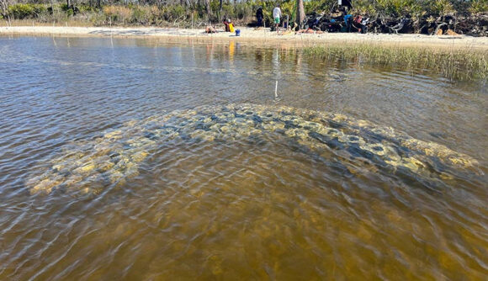
A team of international scientists, including nine Rutgers researchers, reported that a living reef coastal defense system can reduce wave power significantly, suggesting the approach could offer a new way to protect shorelines from storms and rising seas. Their findings provide one of the most detailed tests to date of whether a hybrid reef system, combining living organisms with artificial structures and installed offshore of a military site along the Florida Panhandle, can function as coastal protection infrastructure. “We set out to build a kind of living reef, something that combines natural and engineered materials and can repair itself over time, to help protect coastlines from flooding, erosion and storm damage that are putting both communities and critical infrastructure at risk,” said David Bushek, professor with the Department of Marine and Coastal Studies. Bushek directs the Haskin Shellfish Research Laboratory and is a lead author of the study. “So far, the results are encouraging. What we built is working.”
View of a small, curved reef built from shell bags and mini modules. Made with recycled oyster shells, the structure is already attracting oysters, mussels and barnacles, and will continue to grow over time.

RECENT FACTSHEETS PUBLISHED ON NJAES PUBLICATIONS

E001: Mid-Atlantic Commercial Vegetable Production Recommendations, 2026/2027
Wyenandt, A. and van Vuuren, M.
FS241: Bean Leaf Beetle in the Home Garden
Huq, S., Parulekar, V., and Carll, R.
FS397: Slugs and Snails in the Vegetable Garden
Lowich Held, L. and Carll, R.
Rutgers New Jersey Agricultural Experiment Station is an equal opportunity program provider and employer.

