August 2026
Summer is one of Rutgers' most visible seasons of public engagement, highlighting the breadth of the university's land-grant mission. On the George H. Cook campus in New Brunswick and across New Jersey, the university's youth development, educational outreach, and community food initiatives connect learners of all ages—from elementary and secondary school students to college students and families—while showcasing the New Jersey Agricultural Experiment Station's commitment to strengthening communities through education, healthy food access, and experiential learning.

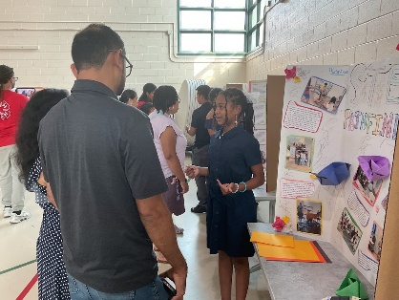
Rutgers 4-H STEM Pathfinders Summer Academy
Twenty-two middle school students from the Trenton area celebrated the completion of the sixth annual Rutgers 4-H STEM Pathfinders Summer Academy with a showcase highlighting projects and experiences from the five-week program. Led by Yaa Owusu-Mensah, 4-H Program Associate, the academy was held at Rutgers Cooperative Extension of Mercer County from July 13 to August 13, providing participants with 134 hours of immersive STEM learning. Weekly activities focused on public health, cybersecurity, engineering, robotics, and agriculture, with students working alongside Rutgers faculty, staff, volunteers, 4-H members, and collaborators from industry, government agencies, and partner universities. Rutgers–New Brunswick Chancellor Dr. Francine Conway attended the closing showcase and met with participants. The academy is designed to strengthen STEM identity among middle school youth by increasing exposure to STEM careers, building practical skills, and fostering the confidence and curiosity needed to pursue future educational and career opportunities.

Climate Resiliency Clubs Launch in New Jersey Schools
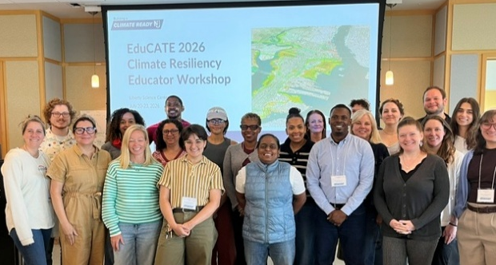
The Rutgers Department of 4-H Youth Development officially launched its Climate Resiliency Clubs initiative with a four-day leadership workshop for educators and administrators held July 20–23 at Liberty Science Center and the Liberty State Park Nature Center. Developed in partnership with the Jacques Cousteau National Estuarine Research Reserve through the Building a Climate Ready NJ initiative, the year-long program will establish Climate Resiliency Clubs in six pilot schools across Hudson and Essex counties. Students will participate in hands-on environmental science, civic engagement, and community-based projects that address local climate challenges while developing leadership skills.

Rutgers NJ 4-H Launches Inaugural Golden Egg Contest
Rutgers Cooperative Extension's Department of 4-H Youth Development partnered with the Atlantic County 4-H Livestock and Poultry Club to launch the inaugural New Jersey 4-H Golden Egg Contest, the first statewide competition of its kind. Open to registered New Jersey 4-H members, the contest introduced youth to the science of commercial egg production while strengthening their knowledge, leadership, and career awareness in agriculture.

Rutgers Community Farmers Market Wellness Events
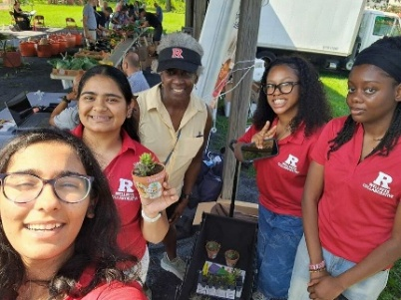
Managed by the Department of Family and Community Health Sciences, the Rutgers Community Farmers Market on Jones Avenue in New Brunswick hosts wellness events that connect gardening, healthy food access, and community well-being. Through activities such as creating a community Tree of Belonging, hands-on gardening with plants from Rutgers greenhouses, and community conversations, participants explore how fresh fruits and vegetables support physical, emotional, social, and environmental health. These events foster community engagement while strengthening Rutgers' partnership with neighboring communities.

USDA NEXTGEN Program Expands Agricultural Career Pathways
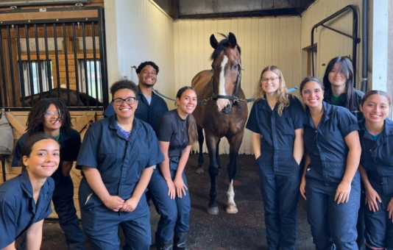
The USDA NIFA NEXTGEN Animal Science Discovery Program (ANSCId) completed its third summer, serving community college students from multiple institutions through immersive residential experiences in animal science, food systems, and a new Sustainable Urban Agriculture track introduced this year. Funded through a five-year, $4.5 million USDA NIFA NEXTGEN award, the ANSCId program prepares under-resourced students for careers in agriculture, veterinary medicine, and related sciences. Hands-on research, mentoring, and experiential learning serves as a pipeline for students from community college to attend Rutgers, training the next generation of professionals for the nation's food and agriculture workforce.
ANSCId program students with a horse from the RU Teaching Herd on the George H. Cook Campus.

Appointment Strengthens Shared Research Facilities to Advance Collaborations and Excellence
James Simon, Distinguished Professor in the Department of Plant Biology, was appointed Faculty Director of SEBS/NJAES Core Facilities, effective July 1. Simon will provide strategic leadership and coordination for the university's shared research facilities, strengthening infrastructure that supports interdisciplinary research across SEBS and NJAES. A nationally recognized researcher with decades of experience leading multi-institutional research initiatives, Simon will help advance collaborations, enhance research capabilities, expand training opportunities for faculty and students, and foster partnerships that reinforce Rutgers' commitment to scientific excellence and public trust in research.
Rutgers Food Systems Team Completes FSM Food Security Initiative
2026 marked the culmination of a multi-year Rutgers food systems research team's community-led food security policy initiative across the Federated States of Micronesia (FSM). Working with FSM state governments, local NGOs, community organizations, and farming households, the interdisciplinary team surveyed more than 1,500 families and stakeholders, culminating in stakeholder review meetings that completed the first full cycle of community-led food security policy co-development across four states.
Historic Ocean Observatory Off the Jersey Coast Returns to Service
The deployment of a floating research platform marks a major milestone in a collaboration among Rutgers, Stockton University, the New Jersey Economic Development Authority, and Ocean Power Technologies Inc. Anchored about three miles offshore of the Rutgers University Marine Field Station in Tuckerton, N.J., the platform—known as the PowerBuoy®—serves as a floating data hub that delivers real-time information on ocean conditions while supporting scientific instruments, education initiatives, and emerging marine technologies.
Rutgers New Jersey Agricultural Experiment Station is an equal opportunity program provider and employer.

