September 2026

Annual Rutgers Turf Field Days Showcase Innovation and Industry Collaboration
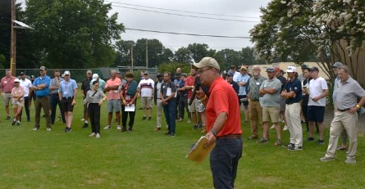
Turf professionals from across the United States and abroad gathered this summer for the 2026 Rutgers Turfgrass Research Field Days, where they explored the latest advances in turfgrass science and management while engaging directly with Rutgers researchers, faculty, staff, and students. Hosted by the Rutgers Center for Turfgrass Science, the annual educational outreach events highlighted cutting-edge research and practical solutions for golf courses, sports fields, lawns, and landscapes, reinforcing Rutgers’ longstanding leadership in turfgrass research and extension. The Golf and Fine Turf Field Day, held July 28 at Rutgers NJAES Hort Farm No. 2 in North Brunswick, welcomed 249 attendees, along with 35 volunteers and 74 Rutgers faculty, staff, and students. The following day, the Lawn, Landscape, and Sports Turf Field Day drew 248 attendees, 31 volunteers, and 47 Rutgers personnel to the Rutgers NJAES Plant Science Research and Extension Farm.
Bradley Park, laboratory researcher in the Department of Plant Biology, presenting on Day 2.

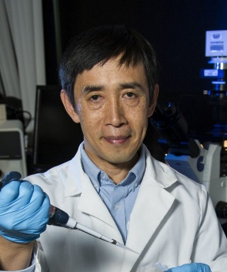
Shellfish Geneticist Ximing Guo to Receive 2026 Edison Patent Award
New varieties of oysters that have become an important part of the global aquaculture industry have earned Rutgers researcher Ximing Guo a 2026 Edison Patent Award from the Research & Development Council of New Jersey (RDNJ). Guo, Distinguished Professor in the Department of Marine and Coastal Sciences, was named the recipient of the Aquaculture Award for his patent, Molluscan Shellfish Produced by Controlled Crossbreeding (U.S. Patent No. 11,266,131). At the Haskin Shellfish Research Laboratory, Guo has developed new oyster varieties for aquaculture in the Mid-Atlantic and Northeastern United States with improved disease resistance, growth, and genetic diversity. The resulting oysters are more uniform, faster growing, healthier, and better suited to commercial production.
Rutgers New Jersey 4-H Camp
Now in its 76th summer, Rutgers New Jersey 4-H Camp continues to provide transformative youth development experiences that foster leadership, environmental stewardship, resilience and community. In 2026, the overnight camp welcomed 708 campers, representing 1,041 camper-weeks, with nearly 70% of participants returning—a testament to the program's lasting impact. Campers engaged in more than 30 educational and recreational activities designed to encourage creativity, independence and personal growth in a technology-free outdoor environment. The fourth year of the Rutgers Gardens 4-H Camp expanded environmental education opportunities, serving 94 campers through hands-on learning about local ecosystems, teamwork and conservation. Across both programs, participants built meaningful friendships, developed leadership skills and strengthened their connection
to nature. Camper and parent testimonials consistently highlighted the camp's inclusive, supportive community and its positive influence on participants' confidence, well-being and personal development, underscoring the enduring value of Rutgers 4-H's experiential youth programming.
FCHS Program Builds Culinary Skills and Confidence
I Can Cook is a Rutgers Cooperative Extension Family and Community Health Sciences (FCHS) program that helps adults with intellectual and developmental disabilities develop culinary skills that promote independence, healthy eating, and greater participation in their communities. Created by Luanne Hughes, FCHS educator of Gloucester County, the program is offered monthly at the Residences at South College Drive in Sewell, on the campus of Rowan College of South Jersey. Through hands-on meal preparation in a supportive, inclusive setting, participants build practical cooking skills while strengthening confidence, decision-making, and self-sufficiency. By equipping individuals to prepare healthy meals independently, I Can Cook supports lifelong healthy habits and demonstrates Rutgers Cooperative Extension's commitment to expanding equitable access to nutrition education and community engagement for all New Jersey residents.

Awards
Rutgers Extension’s 1929 ESP Charter Photo Earns National Historical Recognition

Founded in 1927, Epsilon Sigma Phi (ESP) is the oldest and largest professional organization for Cooperative Extension professionals in the U.S., promoting excellence in Extension through professional development, scholarship, leadership, and recognition of outstanding service. New Jersey established its ESP chapter in 1929, making it one of the earliest state chapters in the nation. The chapter’s Charter and an archival copy of the NJAES newsletter announcing the formation of the chapter, along with the photograph (above) of charter members, were submitted by Rutgers Cooperative Extension, earning the top award in the ESP’s “Oldest Charter Photo” contest.
ANR Faculty and Staff Garner National, Regional, and State Honors
The 2026 Annual Meeting and Professional Improvement Conference, hosted by the National Association of County Agricultural Agents (NACAA), was held in Denver, Colorado, and attracted more than 1,200 extension educators, agricultural agents, and specialists. The following Agriculture and Natural Resources faculty and staff were recognized:
  - National Awards: Jean Epiphan; Steve Yergeau
  - Northeast Regional Awards: Patrick McMullen; Kate Brown; Claudia Gil Arroyo; Claudia Urdanivia; Rebecca Magron; Steve Yergeau; Tim Waller; Bill Errickson; Erin Quinn; Steve Rettke
  - State Awards: Bill Errickson; Michelle Infante-Casella; Steve Komar; Bill Bamka; Tim Waller
  - National Finalist: Kate Brown; Claudia Gil Arroyo; Claudia Urdanivia
  - Third Place: Lauren Errickson; Alex Sawatzky; Bill Errickson
In the News
NBC10 Philadelphia interviews Thomas “Motz” Grothues, director of the Rutgers University Marine Fields Station, and Lisa Auermuller, administrative director of the Megalopolitan Coastal Transformation Hub, about rising sea levels at the Jersey shore and the treat to the field station.
National Public Radio (NPR) interviews Tom Orton and Pete Nitzsche about Scarlet Sunrise, the bi-color grape tomato that they developed and what it takes to make a new, branded tomato.
Rutgers New Jersey Agricultural Experiment Station is an equal opportunity program provider and employer.

