October 2026

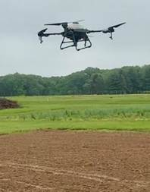
Agricultural Drone Working Group Expands Training Opportunities for NJ Farmers
Agricultural drones offer farmers new opportunities to improve field monitoring, support crop management, and explore more efficient farming practices. To help farmers access this emerging technology, Rutgers Cooperative Extension is advancing agricultural drone education and outreach through a new Mid-Atlantic Agricultural Drone Working Group. Rutgers Cooperative Extension agricultural agent Stephen Komar (Sussex), who leads the group, is working alongside RCE colleagues William Bamka (Burlington) and Michelle Infante-Casella (Gloucester) to bring together land-grant university personnel in the mid-Atlantic region working with agricultural drones to foster networking and collaboration in education, research, and outreach. The group held its first virtual meeting on September 29 to plan future activities. As part of this regional effort, the Rutgers Agricultural Drone Team is offering a two-day training opportunity for New Jersey commercial farmers on November 6 and 13, 2026, at Rutgers Snyder Research Farm in Pittstown, NJ. Funded through a three-year U.S. Department of Agriculture Sustainable Agriculture Research and Education (SARE) Professional Development Grant, the training is offered at no cost to participating in-state farmers. The program will help participants prepare to obtain the Federal Aviation Administration (FAA) Remote Pilot Certificate (Part 107), required for commercial drone operations. Training will include resources to help farmers prepare for the certification examination, followed by hands-on instruction and opportunities to fly drones at the research farm. The initiative aims to equip farmers with the knowledge and practical skills to explore drone technology for agricultural applications on their own farms.
Rutgers New Jersey 4-H Welcomes 2027 Agriculture Ambassador Cohort
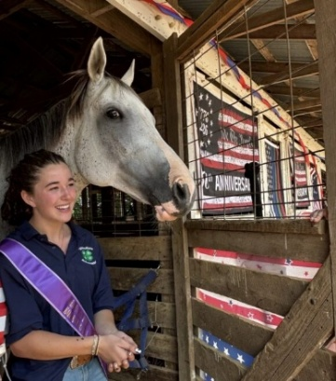
The future of agriculture depends on young people who can champion the industry, communicate its value, and help shape its direction. Fourteen Rutgers New Jersey 4-H members from eight counties have been selected for the 2027 4-H Agriculture Ambassador Program, a statewide leadership initiative preparing teens to represent and promote agriculture across New Jersey, and led by Melissa Bright, 4-H agent, Somerset County. Launched in fall 2024 through a partnership between National 4-H Council and Nutrien, a global agricultural company, the program gives high school youth opportunities to deepen their understanding of agriculture while developing skills in leadership, public speaking, communication, and advocacy. Open to active New Jersey 4-H members in grades 9 through 13, the program welcomes teens with interests spanning farming, animal science, food systems, and natural resources. Throughout the program year, ambassadors will connect with agricultural industry professionals, explore career pathways, and learn about current issues affecting the industry. According to Bright, “Educational programs, agricultural tours, leadership development experiences, and outreach activities help them build confidence in communicating agriculture’s importance to diverse audiences.”
Avery (Gloucester County 4-H) is a part of the program.

New FCHS Minors Advance Health Equity and Holistic Wellness
In their first year, the Department of Family and Community Health Sciences (FCHS)’s two newly launched interdisciplinary minors in Health Equity and Holistic Wellness attracted 32 enrolled students, including 20 in Holistic Wellness and 15 in Health Equity. Three students completed the Holistic Wellness minor in May 2026. Both minors advance RCE’s mission by connecting undergraduate learning with community needs through Extension-based partnerships. Each minor draws on faculty from five or more schools across the university. Health Equity students explore topics through courses such as Housing Inequality & Homelessness, Food for All: Transforming Food Systems for Health, and Education Policy & Social Justice. Holistic Wellness students take courses such as Wellness Behavior, Introduction to Arts in Health, and Nutrition and Health. Through these interdisciplinary learning experiences, students develop skills to strengthen health equity and promote well-being in the communities where they live and work.
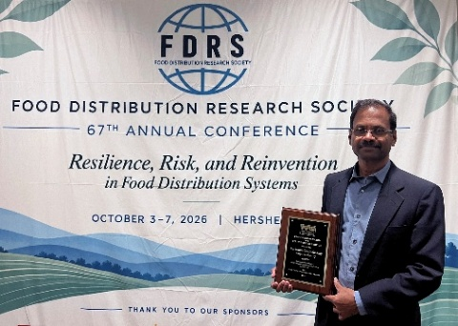
AWARDS
Ramu Govindasamy, professor in the Department of Food, Agricultural and Resource Economics, was presented with the Frank Panyko Distinguished Service Award from the Food Distribution Research Society (FDRS), one of the organization's highest honors recognizing sustained leadership, service and contributions to the field of food distribution research. The recognition honors Govindasamy received the award during the FDRS’ Annual Conference, held October 4–6, in Hershey, PA, for more than 20 years of leadership, scholarship and service in agricultural marketing and food distribution.
Stacy Bonos, professor of turfgrass breeding in the Department of Plant Biology, is the recipient of the Fred V. Grau Turfgrass Science Award from the Crop Science Society of America. The award recognizes individuals who have made significant career contributions and excellence in research, education, extension, industry leadership, and service in turfgrass science. Bonos is also the director of the Rutgers Turfgrass Breeding Program and the associate director of the Center for Turfgrass Science.

Grant
Jennifer Sun, assistant professor in the Department of Biochemistry and Microbiology, was awarded a $2.1 million National Institutes of Health MIRA grant to study how microbes influence insect sensory behavior. The research aims to develop precise, species-specific pest control methods as alternatives to conventional insecticides. Bugs are formidable foes, spreading disease and destroying billions of dollars in crops annually. Conventional controls, such as insecticides, are losing their effectiveness amid growing resistance and environmental concerns. Novel controls are needed and Sun’s research could help identify new ways of controlling insect pests that are safe and effective.

Research
Rutgers scientists have identified natural compounds that repel spotted-wing drosophila, an invasive fruit fly that threatens blueberry production. The discovery, led by Beth Ferguson, a postdoctoral researcher at the Philip E. Marucci Center for Blueberry and Cranberry Research, revealed that yeast associated with a common fruit fly repelled the pest and significantly reduced egg-laying. The findings could support nonchemical pest management strategies, reducing reliance on costly insecticides that may harm beneficial organisms. Further research is needed to assess field effectiveness, but the discovery offers promise for protecting New Jersey’s blueberry industry, which produced 47.5 million pounds of blueberries, with a production value of more than $94 million.
Rutgers New Jersey Agricultural Experiment Station is an equal opportunity program provider and employer.

